Design Patterns – Rodrigo Mesquita 57372

Class location:
\ganttproject\ganttproject\src\main\java\net\sourceforge\ganttproject\document\ReadOnlyProxyDocument.java

This pattern is a Proxy. It allows a proxy class to represent a real class, in this case, this proxy class represents read only documents (verified with the canRead() and canWrite() methods).
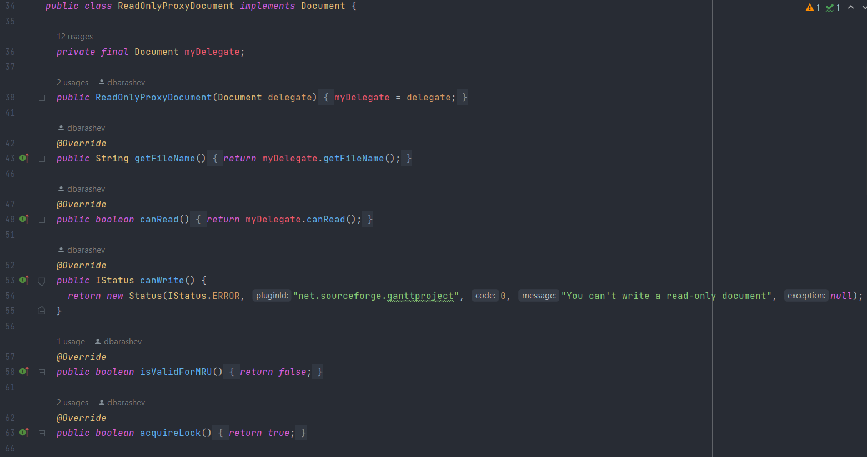

Class location:
\Java\jdk-17.0.2\lib\src.zip!\jdk.jdi\com\sun\tools\jdi\TargetVM.java

This design pattern is a Singleton because that is the only instance in the EventController class.
